# ***CHARTING THE COURSE OF INNOVATION : A STARTUP ANALYSIS***

## INTRODUCTION

### 1.1 Overview

###### A startup is a company in the early stages of development that is set up by one or several people to enter an existing market with unique products or services . Startup companies often face insufficient capital to fund their business operations to be at the same level as already established companies . As a result , the prime source of funding comes from the founders friends and families .

###### India has over 61, 400 startups recognized by the department of promotion of industry and internal trade (DPIIT) , with at least 14,000 recognized during fiscal 2022 , according to the economic survey 2021 - 2022 . A startups in India have grown remarkably over the last six years . The datasets are exhaustive in its demonstration of startups in state wise . This data set contains a record of startups in each states of India , here we are going to analyse State wise , Region wise and Overall startups in India .

### 1.2 Purpose

###### In this project we analyse the startup analysis from 2017 to 2022 . The purpose of this program is to know how much startups are created , how to analyze it and the benefits of startup analysis . The primary purpose is to answer market demand by creating new and innovative products or services . While most small business might intend to stay small , a startup focuses on fast growth in a designated market . Usually , such companies start as an idea and gradually grow into a viable product , service or platform . It gives you a clear picture of your business financial health so that you can make informed decisions about where to allocate resources .

###### Through this project we can reduce the competitions that are going between companies .

## PROBLEM DEFINITION & DESIGN THINKING

### Empathy Map

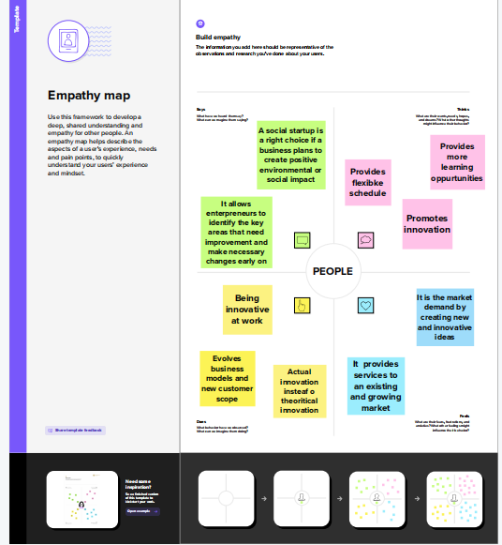

### Ideation & Brainstorming map

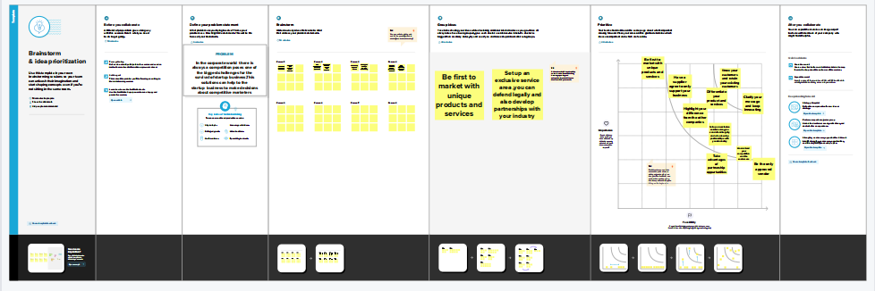

## RESULT

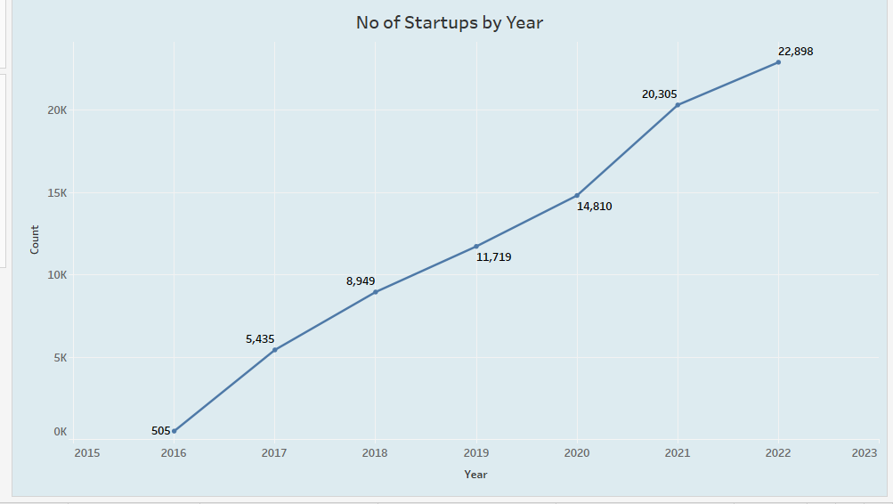

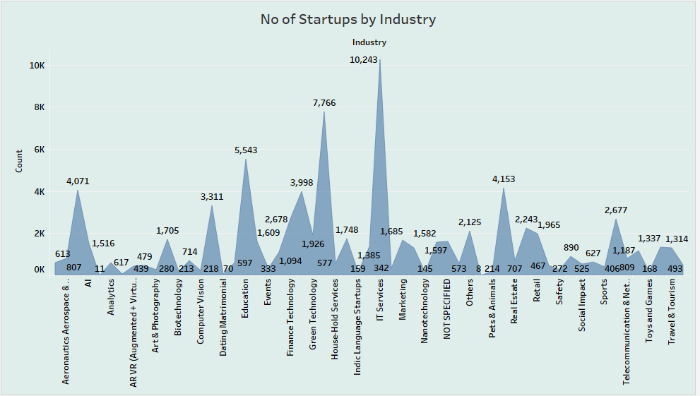

## SS3

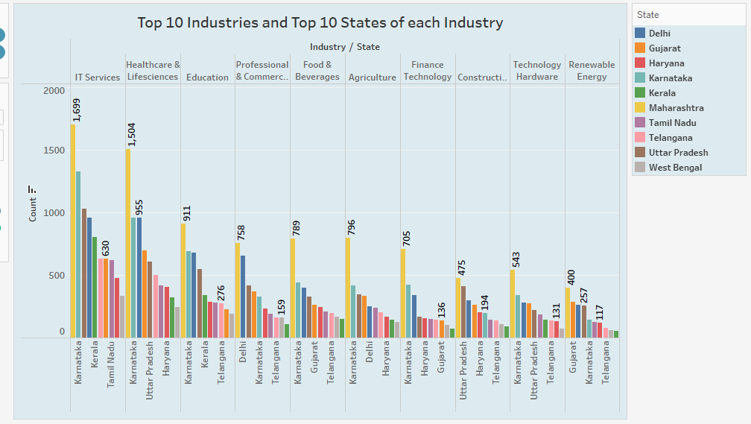

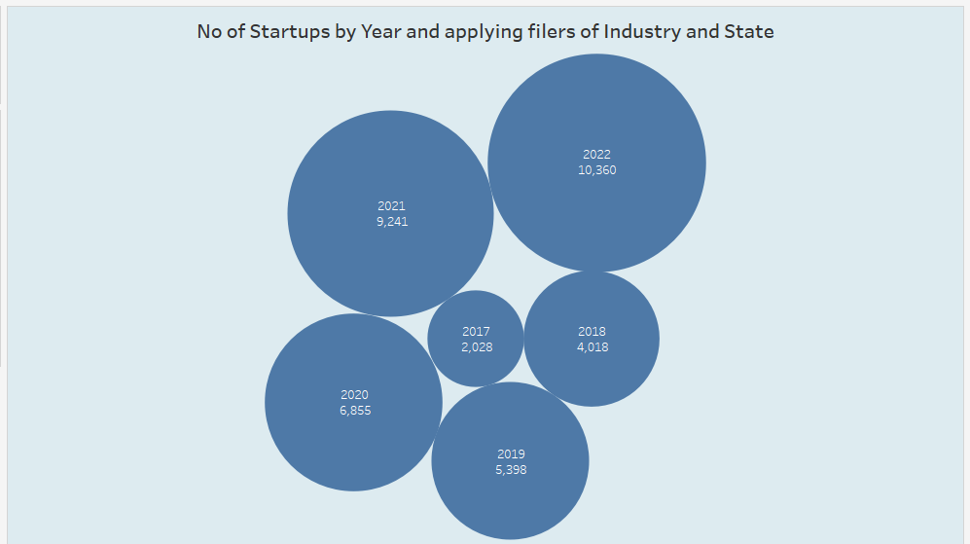

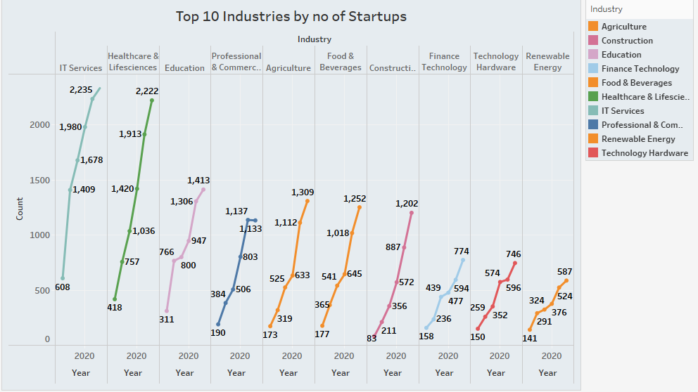

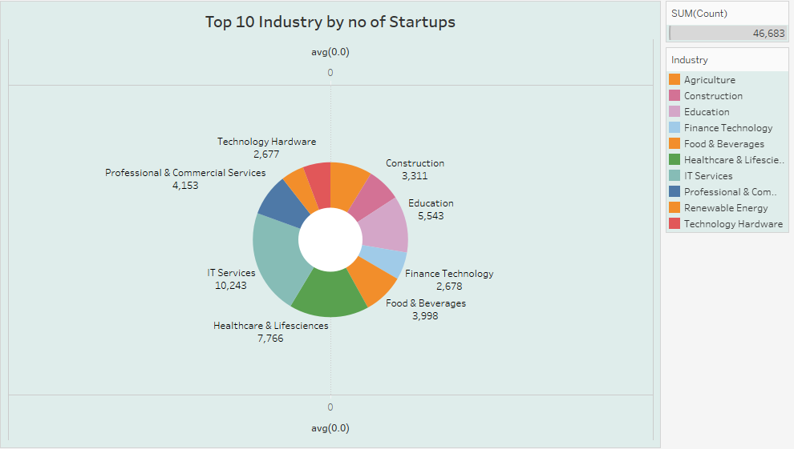

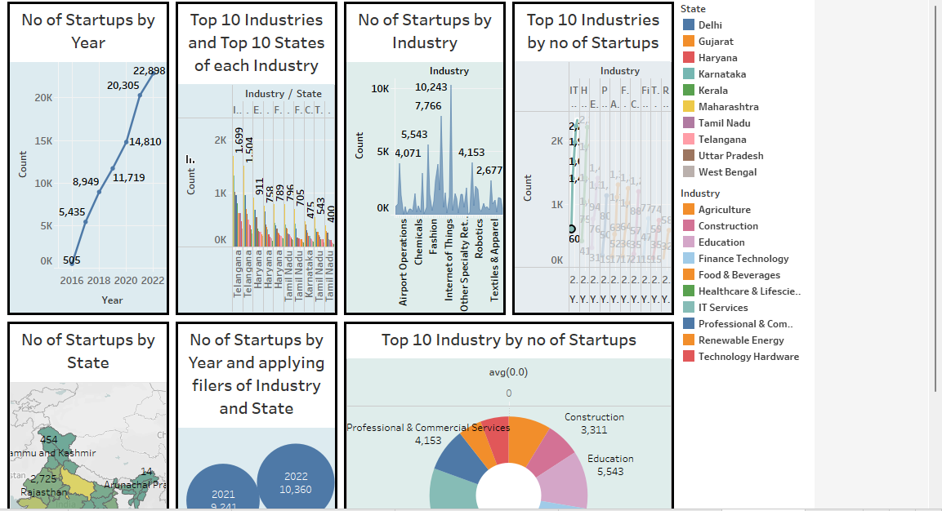

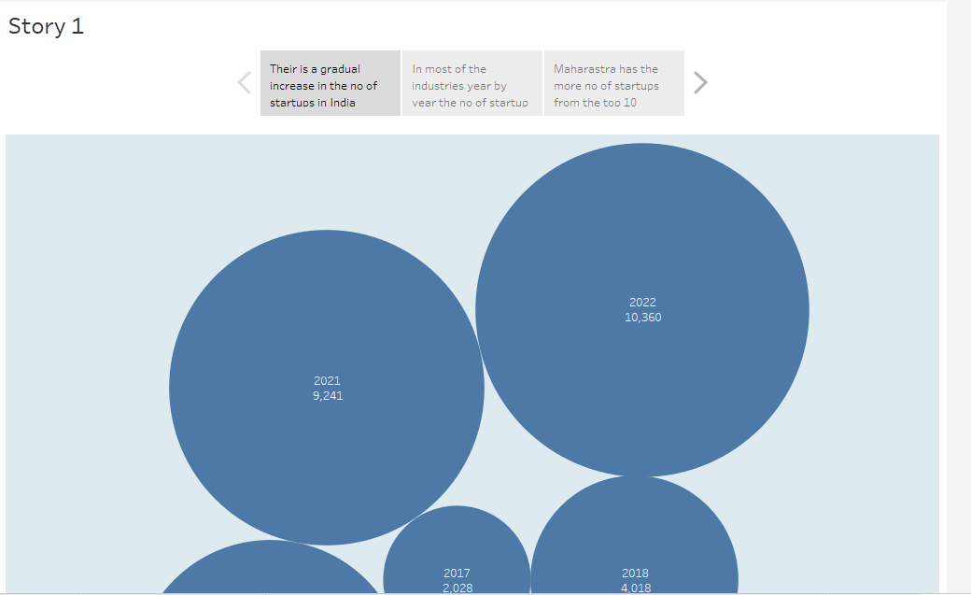

## ADVANTAGES & DISADVANTAGES

* Opportunities for innovation
* Increased job satisfaction
* More rewarding work

###### Flexible hours and work-from-home options

* Unclear job description and KPIs
* Lack of structure
* No stability

###### According to the US Champers Of Commerce , small business such as Delivery services , Bakeries , Gardening supplying Companies ,etc., flourished more during the pandemic . More and more people volunteered for door-to-door delivery services .

Plenty of startup companies are launched in the global market every month , but success is not guaranteed for every one of them . Poor leadership skills , faulty business models , and indiscipline can turn down the table for your startup . These are the drawbacks faced by many entrepreneurs .

## APPLICATIONS

###### These startups are simultaneously enabling more jobs than large companies or enterprises in the same industry . Therefore curbing the unemployment problems in developing nations like India . Many multinational corporations are now outsourcing their tasks to small business in order to ocus on their core competencies .

###### In this project data analytics with tableau is used to easy understanding visualizations through pie , bar , maps etc.,

## CONCLUSION

###### A favorable environment or startups has been created , which should maintain itself and produce significant rewards in the future . This environment has been created by lowering the requirements needed to launch a firm and by offering programs for startups to access bank financing .

## 7.FUTURE SCOP

###### India can be considered a youthful country as it has been 65 years of its independence . Startups are small companies but they play a big role in the economic process . They create more jobs which insinuates more employment .